**Assignment-1**

**Name:-** R Sujith

**Reg No:-** 21BCE7696

**Course:-** Data Analytics collaboration with ibm

Cognos

**Branch:-** VIT-AP(Amravati)



**Challenge:-**

Upload the dataset to Cognos Analytics, delete the unnecessary columns, create a data module, explore and visualize the dataset.

First we upload the supermarket excel sheet into IBM website.

And then we do some operations in data module adding or deleting the columns. Here the unnecessary columns are from my perspective is time. Because from time we don’t get any information or any help from visualization. And then I have split the date into year, date, month and day of the week.

**Supermarket data module:-**

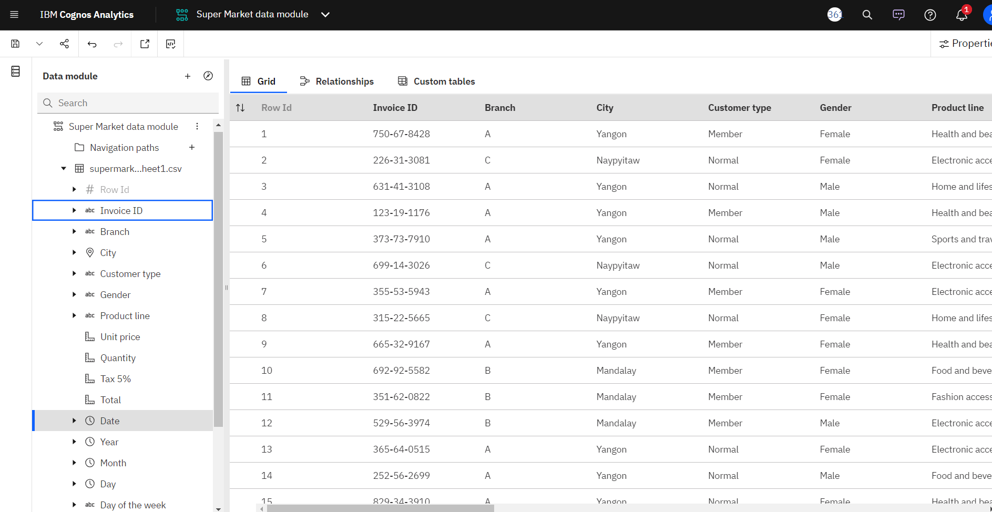

**Explore and Visualization: -**

**Bar Chart:-**

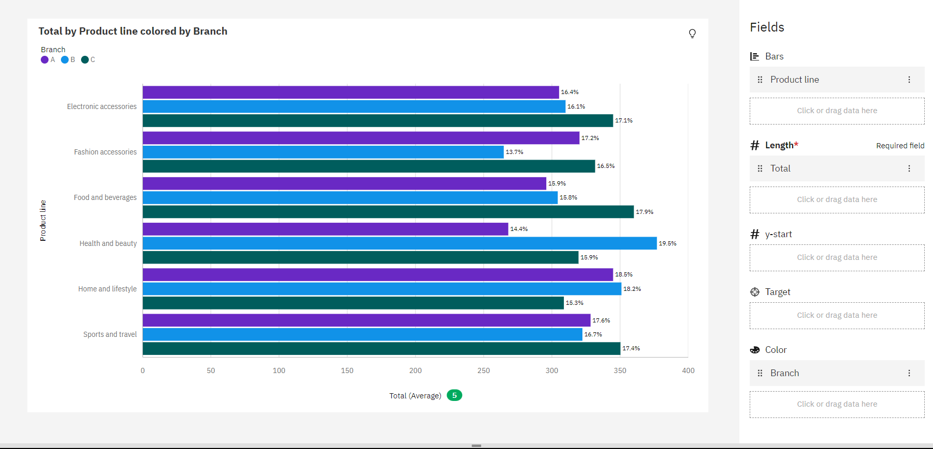

**Pie Chart:-**

**Map Chart:-**

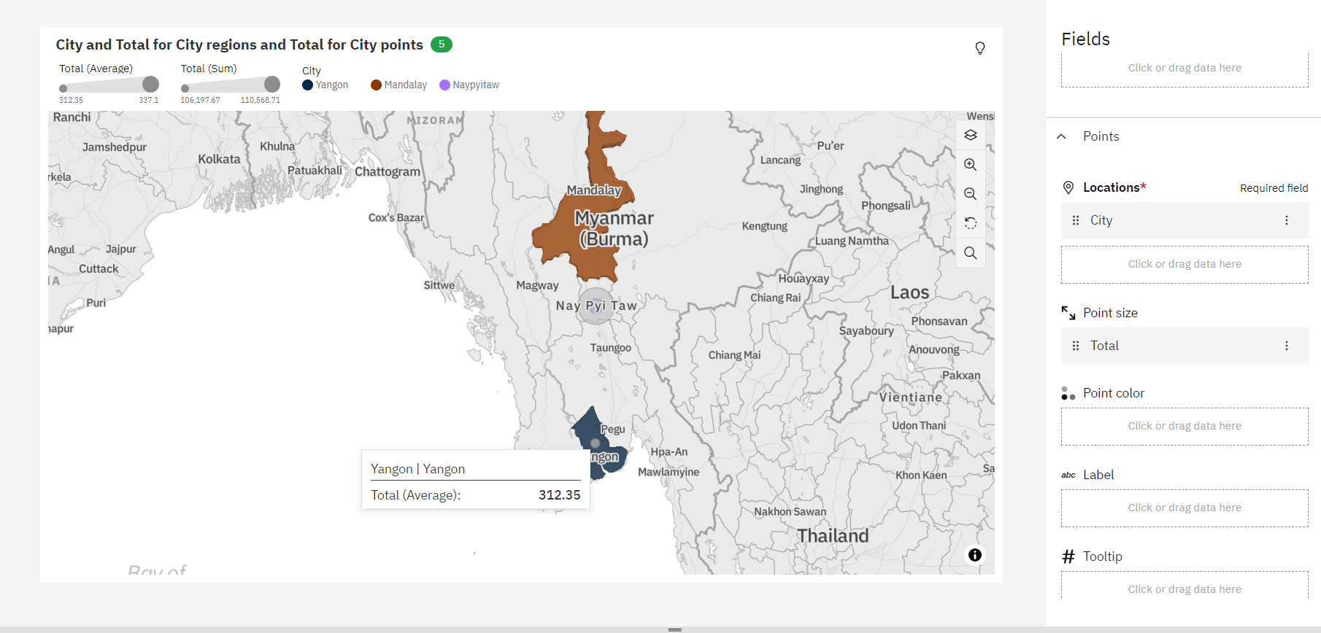

**Bubble Chart:-**

**Area Chart:-**

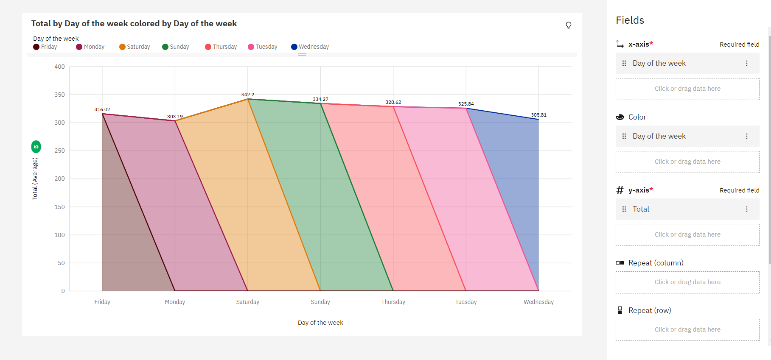

**Stacked Column Chart:-**

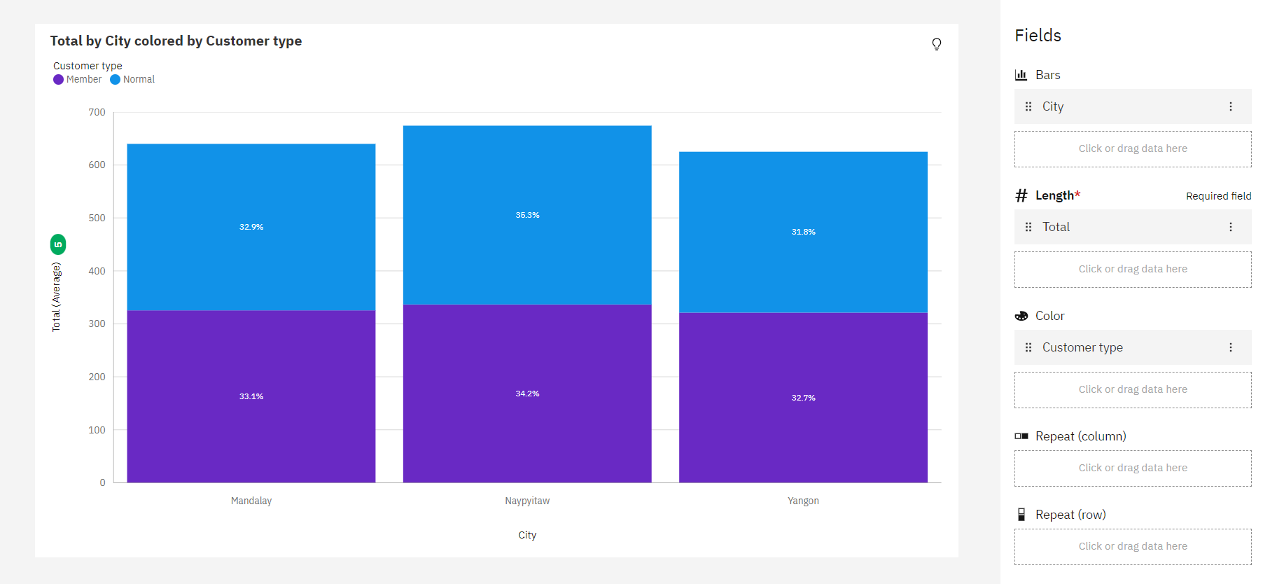

**Line and Column Chart:-**

**Box Plot:-**

**Scatter Plot:-**

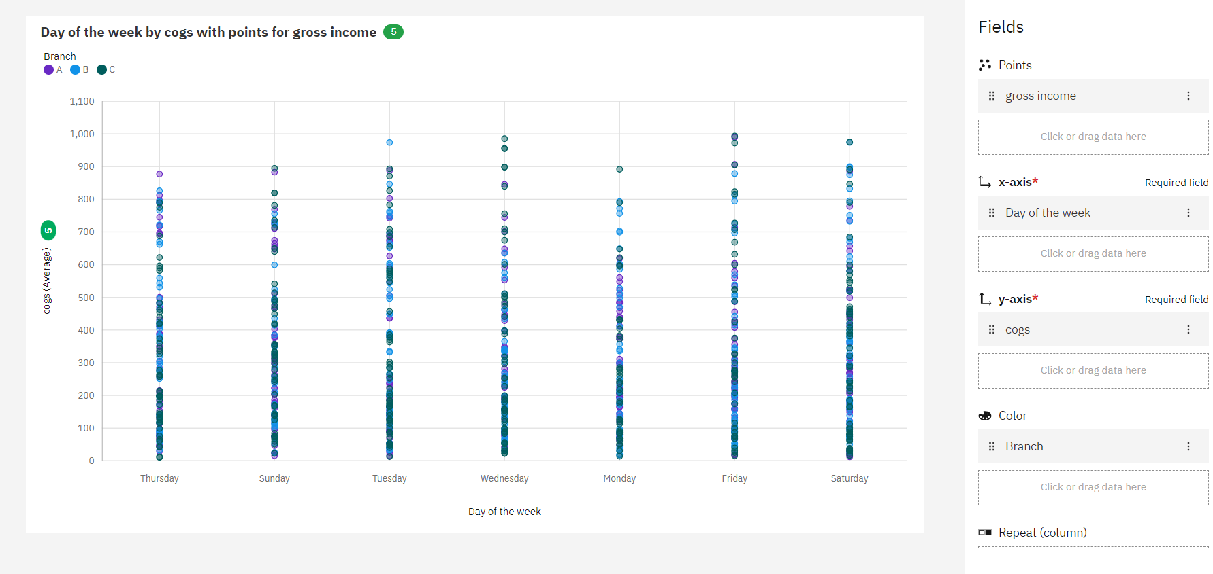

**Radial Chart:-**

**Hierarchy Bubble Chart:-**

**Heat Map Chart:-**

**Tree Map Chart:-**

